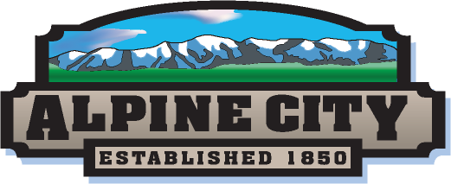
Seasonal Park Maintenance Technicians

Alpine City
20 North Main
Alpine, Utah 84004
(801) 756-6347 ext. 1

Job Title: Seasonal Park Maintenance Technicians
Department: Public Works
Reports to: Public Works Director/City Engineer
Status: Full-Time (hourly, no benefits)
Wage: $9.50 - $10.50 per hour, DOQ
Close Date: Open until filled
Hours: Approximately 40 hours per week

Position Summary:
Alpine City currently has several openings for Seasonal Park Maintenance Technicians. This is a seasonal position with the Public Works Department of approximately 40 hours per week. This position performs a variety of semi-skilled and skilled work pertaining to landscape maintenance, maintenance of Alpine City parks, streetscapes, park facilities and other Alpine City property. The technician will work under the direction of the Public Works Director but will be assigned to provide support to one or more experienced Public Works/Parks Lead workers.

Required Knowledge, Skills and Abilities:
- Work requires basic knowledge of park maintenance operations, use of hand tools and grounds keeping equipment, use of janitorial equipment, and use of protective equipment.
- Operates lawn mowing equipment.
- Applicants must be willing to establish and maintain effective working relationships with others, communicate effectively, take direction from others they are assigned to work under, and tolerate weather extremes in the work place.
- Assist other crew members as needed/directed and perform duties as deemed necessary.
- Considerable emphasis is placed on working in a team-oriented environment.

Physical Demands:

The physical demands described here are representative of those that must be met by an employee to successfully perform the essential functions of this job.

While performing the duties of this job the employee is frequently required to stand, sit, reach with hand and arms, talk, hear, see, walk, stoop, kneel, crouch or crawl, use hands to grab and handle or feel and lift up to 80 pounds. The employee must occasionally lift and/or move more than 80 pounds. Duties require sufficient mobility to work in field and shop settings.

Work Environment:
The work environment characteristics described here are representative of those an employee encounters while performing the essential functions of this job.

While performing the duties of this job, the employee is frequently exposed to weather extremes (hot and cold); working after hours in emergency situations; and working both in the field and in shop settings.

Minimum Qualifications:
- Applicants must be at 16 years of age.
- Previous experience in parks maintenance, landscaping, or related field is preferred, but not required.
- The successful candidate will be required to pass a criminal background investigation.
- Must have a valid Utah driver’s license.

Application instructions:
Qualified applicants must sign and submit a completed Alpine City employment application to the Alpine City Human Resources Department. The employment application can be obtained at the Alpine City Hall or online at www.alpinecity.org. Completed applications may be submitted via email (send to cortnie@alpinecity.org), or at the Alpine City Hall. Applications received after the position close date will not be considered. All sections of the application must be completed and legibly filled in. Additional information may be attached if necessary. Applications that are incomplete, that do not specify the job applying for or that list multiple positions will not be considered.

Applicants needing further information regarding the position or needing assistance due to a disability should contact Cortnie Graham, cortnie@alpinecity.org.

